XKCD Comic 162 – Angular Momentum

Josh Orndorff
admin@joshorndorff.com

05 September 2012

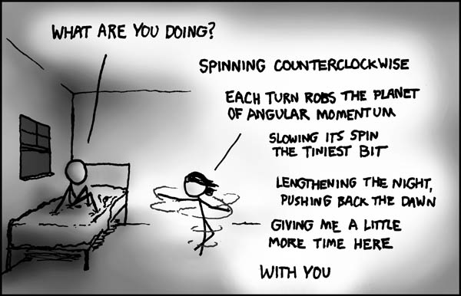
The premise of Randall's problem is that the girl will acquire some angular momentum which, by conservation of angular momentum, will be taken from the Earth. As long as she spins, the Earth will spin more slowly thereby prolonging the couple's night together. The question at hand is how much longer she can make the night last by spinning. (And also is it worth it if she throws up). Randall notes that whatever the answer, sunrise always comes too soon. But what the heck, let's do the calculation anyway shall we?

Section 1 – Theory
I will model the earth as a uniformly dense sphere, and the girl as a uniformly dense cylinder. Their respective moments of inertia can be derived by integrating . But since I'm modeling them with simple geometric shapes, the established moments can easily be looked up (for example, see wikipedia). To avoid numerous subscripts, capital letters will represent the Earth's quantities, and lower case letters will represent the girl's quantities.

The three relevant angular momenta (l of the girl, L₀ before she starts spinning, and L_{f} after she starts spinning) can then be calculated using.

To solve for the Earth's new rotation rate after the spinning begins, we use the angular momentum conservation equation and substitute the preceding expressions. However, we must realize that her effectiveness depends on her latitude as only one component of the girl's acquired angular momentum (the component along the Earth's rotation axis) contributes. Further, since the comic specifies that the girl is spinning counterclockwise (presumably as viewed from above), if she is in the southern hemisphere, she will actually speed the earth up. If we call her latitude φ then the correct conservation for this component is:
North Pole
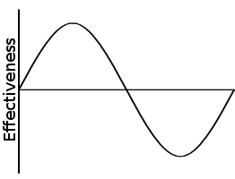

φ

South Pole

And now that we have the Earth's new angular momentum, we can calculate the difference in the length of a night.

Section 2 – The Numbers
In principle that does it, but in practice we haven't answered the question at all. How many extra hours can we earn? Let's look up the relevant data about the Earth, and make some reasonable assumptions about the girl. A typical girl (or at least the one I'm interested in) is probably roughly 50 kg, about 150 cm tall, has a shoulder radius of a little less than 25 cm, and could likely spin at about 40 rpm without puking right away. For definiteness, let's assume she is in northern Ohio (latitude: 42° N), is named Maggie, and rocks a bad-ass biker chick look. These data are summarized in the table and photo.
Earth | Girl
M = 5.97 × 10 ²⁴ kg | m = 50 kg
Ω₀ = 7.27 × 10 ⁻⁵ rad/s | ω = 4 rad/s
R = 6.378 × 10 ⁶ m | r = .25 m
φ = 42° | h = 1.5 m

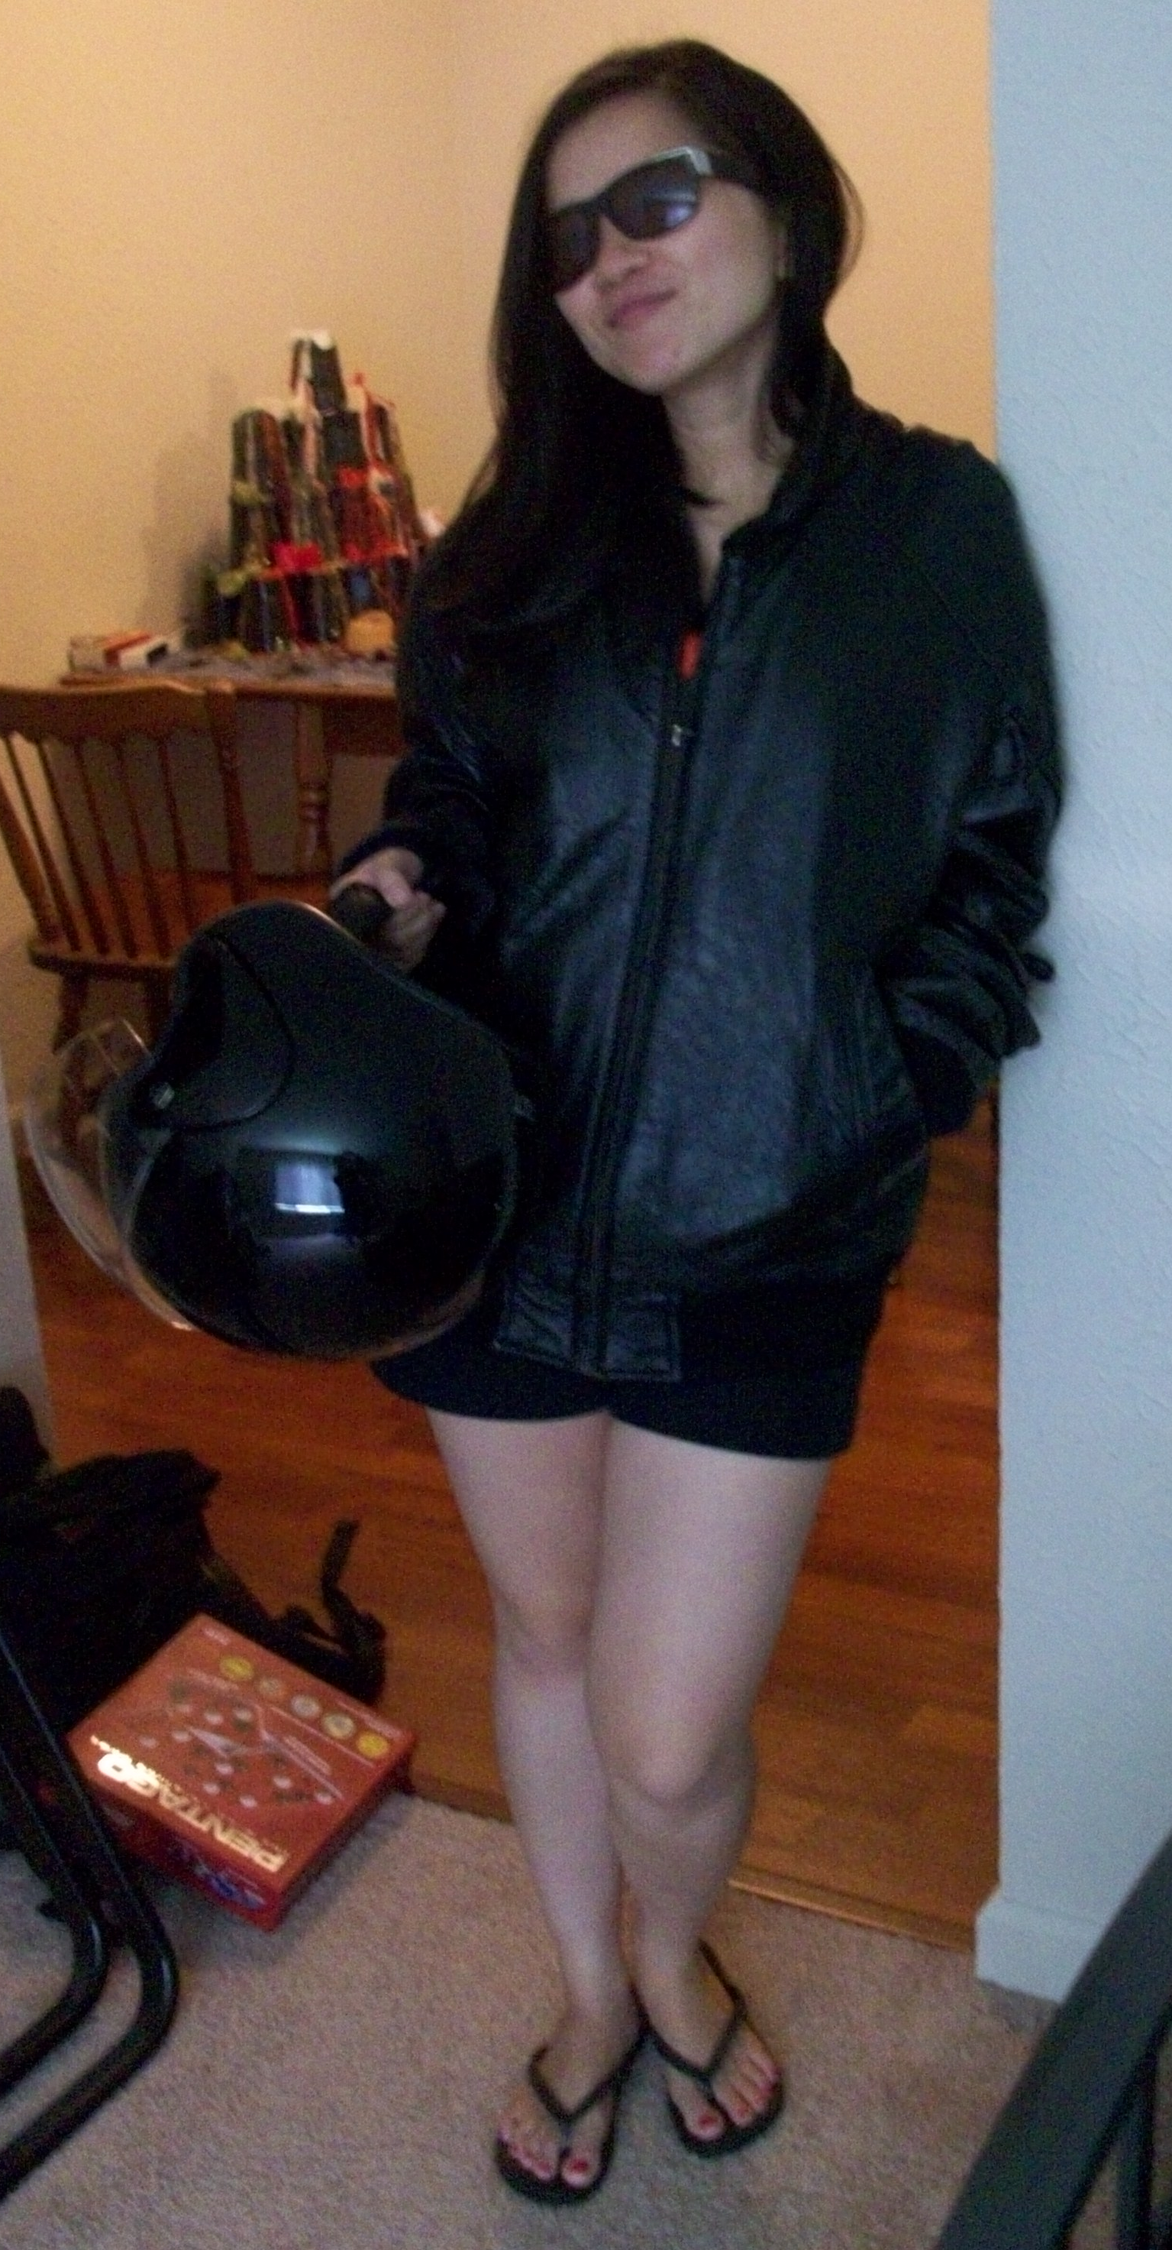
Plugging the numbers into the scale factor above gives us a ratio of:

So if Maggie were to do her spinning on a night that would have otherwise lasted twelve hours, she would gain an extra ~2.6 × 10⁻²⁹ seconds, or 0.000026 yoctoseconds. They don't make metric prefixes small enough.

Definitely worth it for extra time with this girl.

